**Assignment -3  
 Implement java assignment for java JDBC using java**

**Creating table into database using Java JDBC:**

**import** java.sql.*;

**public** **class** assignment1 {

**static** **final** String ***JDBC_DRIVER*** = "com.mysql.cj.jdbc.Driver";

**static** **final** String ***DB_URL*** = "jdbc:mysql://localhost/mad";

**static** **final** String ***USER*** = "root";

**static** **final** String ***PASS*** = "";

**public** **static** **void** main(String[] args) {

Connection conn = **null**;

Statement stmt = **null**;

**try** {

Class.*forName*(***JDBC_DRIVER***);

conn = DriverManager.*getConnection*(***DB_URL***, ***USER***, ***PASS***);

stmt = conn.createStatement();

String sql = "CREATE TABLE mytable ("

+ "id INT(11) NOT NULL AUTO_INCREMENT, "

+ "name VARCHAR(50) NOT NULL, "

+ "age INT(3) NOT NULL, "

+ "PRIMARY KEY (id)"

+ ")";

stmt.executeUpdate(sql);

System.***out***.println("Table created successfully");

} **catch** (SQLException se) {

se.printStackTrace();

} **catch** (Exception e) {

e.printStackTrace();

} **finally** {

**try** {

**if** (stmt != **null**)

stmt.close();

} **catch** (SQLException se2) {

}

**try** {

**if** (conn != **null**)

conn.close();

} **catch** (SQLException se) {

se.printStackTrace();

}

}

}

}

**OUTPUT :-**

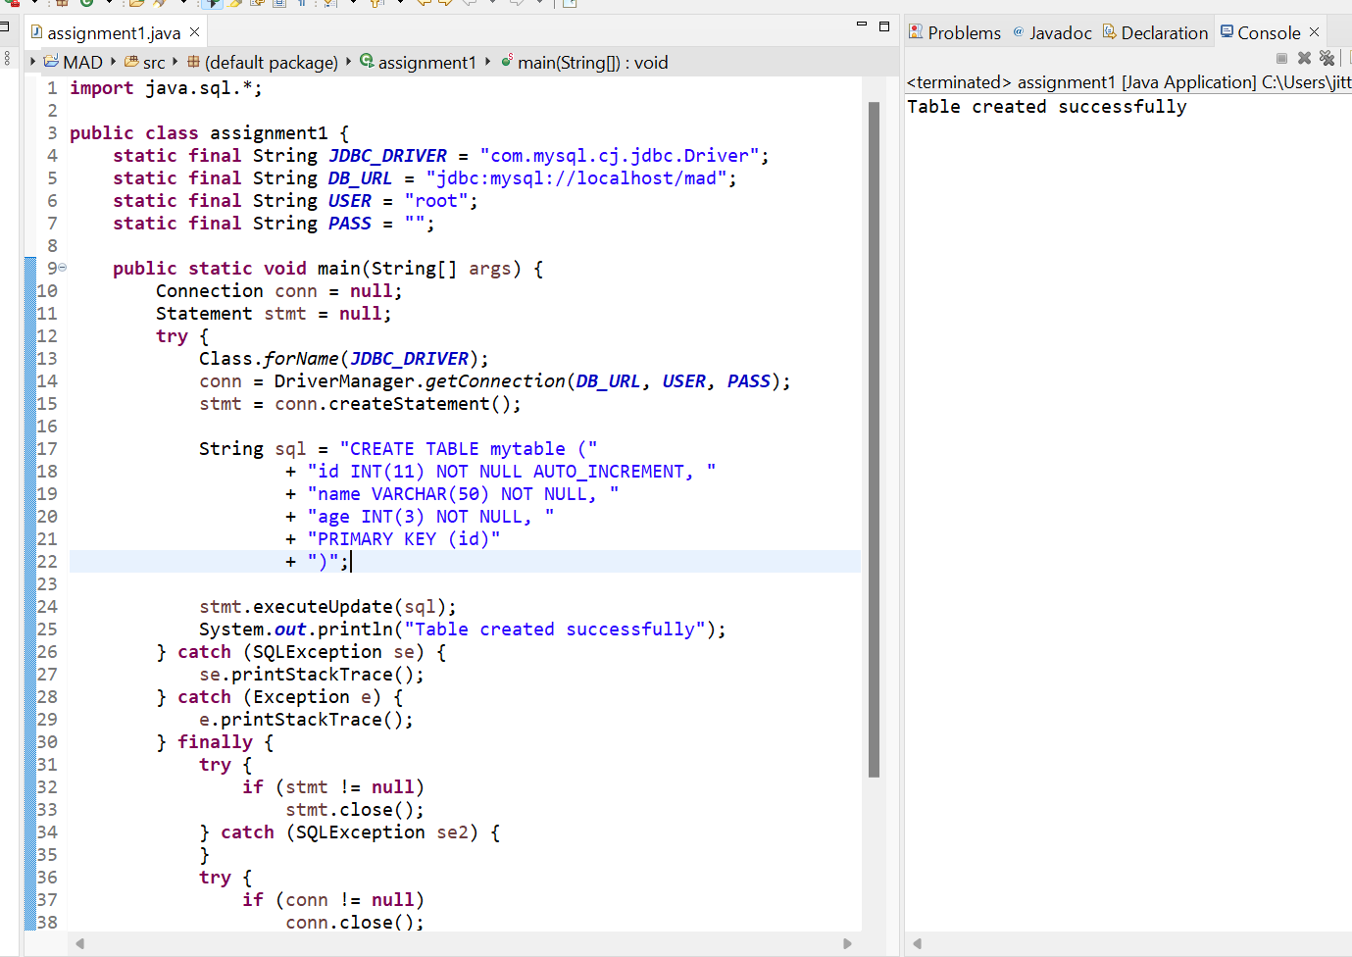

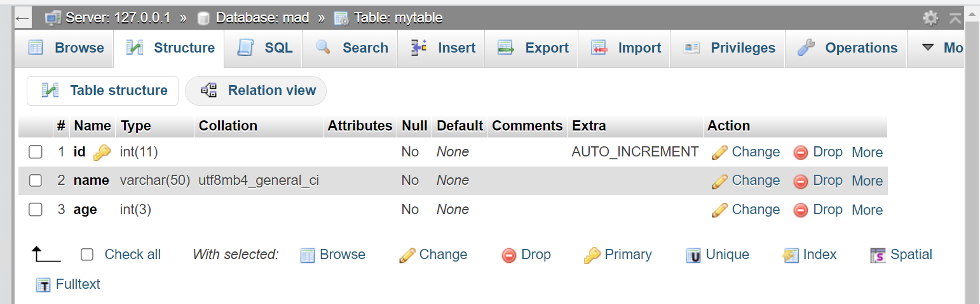

**Inserting values into table using Java JDBC :**

**import** java.sql.*;

**public** **class** assignment1 {

**static** **final** String ***JDBC_DRIVER*** = "com.mysql.cj.jdbc.Driver";

**static** **final** String ***DB_URL*** = "jdbc:mysql://localhost/mad";

**static** **final** String ***USER*** = "root";

**static** **final** String ***PASS*** = "";

**public** **static** **void** main(String[] args) {

Connection conn = **null**;

Statement stmt = **null**;

**try** {

Class.*forName*(***JDBC_DRIVER***);

conn = DriverManager.*getConnection*(***DB_URL***, ***USER***, ***PASS***);

stmt = conn.createStatement();

String sql = "INSERT INTO mytable (name, age) VALUES ('John Doe', 25)";

stmt.executeUpdate(sql);

sql = "INSERT INTO mytable (name, age) VALUES ('Jane Smith', 30)";

stmt.executeUpdate(sql);

System.***out***.println("Values inserted successfully");

} **catch** (SQLException se) {

se.printStackTrace();

} **catch** (Exception e) {

e.printStackTrace();

} **finally** {

**try** {

**if** (stmt != **null**)

stmt.close();

} **catch** (SQLException se2) {

}

**try** {

**if** (conn != **null**)

conn.close();

} **catch** (SQLException se) {

se.printStackTrace();

}

}

}

}

**OUTPUT :-**

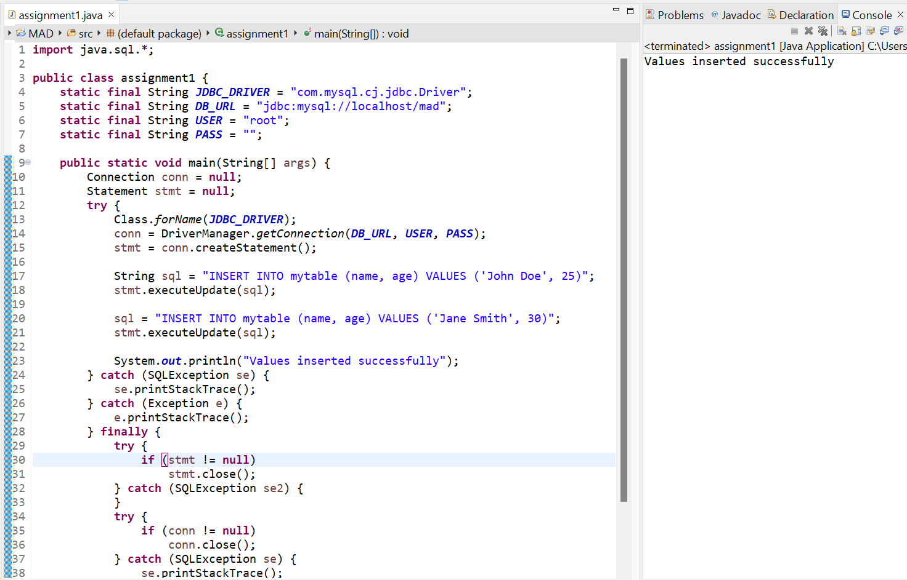

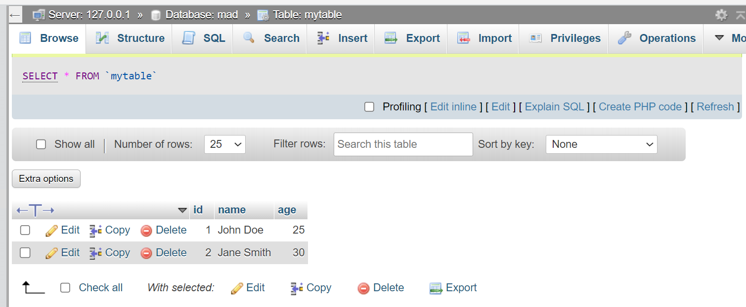

**Displaying the table in the database using Java JDBC :**

**import** java.sql.*;

**public** **class** assignment1 {

**static** **final** String ***JDBC_DRIVER*** = "com.mysql.cj.jdbc.Driver";

**static** **final** String ***DB_URL*** = "jdbc:mysql://localhost/mad";

**static** **final** String ***USER*** = "root";

**static** **final** String ***PASS*** = "";

**public** **static** **void** main(String[] args) {

Connection conn = **null**;

Statement stmt = **null**;

**try** {

Class.*forName*(***JDBC_DRIVER***);

System.***out***.println("Connecting to database...");

conn = DriverManager.*getConnection*(***DB_URL***, ***USER***, ***PASS***);

System.***out***.println("Creating statement...");

stmt = conn.createStatement();

String sql = "SELECT * FROM mytable";

ResultSet rs = stmt.executeQuery(sql);

**while** (rs.next()) {

**int** id = rs.getInt("id");

String name = rs.getString("name");

**int** age = rs.getInt("age");

System.***out***.println("ID: " + id);

System.***out***.println("Name: " + name);

System.***out***.println("Age: " + age);

System.***out***.println("--------------------");

}

rs.close();

stmt.close();

conn.close();

} **catch** (SQLException se) {

se.printStackTrace();

} **catch** (Exception e) {

e.printStackTrace();

} **finally** {

**try** {

**if** (stmt != **null**) stmt.close();

} **catch** (SQLException se2) {

se2.printStackTrace();

}

**try** {

**if** (conn != **null**) conn.close();

} **catch** (SQLException se) {

se.printStackTrace();

}

}

}

}

**OUTPUT: -**

